Monthly P&L Application

## Instructions

Instructions for “Monthly P&L Application”

**Please read and follow all the instructions for a proper use of the application!**

## Pre-requisites:

1. **The Monthly Trial Balances** - they should be stored in the same folder, in .xlsx format, and each file needs to be renamed with numbers according with the month (ex: 1, 2, 3 for Jan, Feb, March).

1. If the monthly trial balances share the same format, ***modify ONLY the header for the first month*** with the one down below:

|  |  |  |  |  |  |
| --- | --- | --- | --- | --- | --- |
| Cont | Denumire cont | Debitor inceput an | Creditor inceput an | Debitor luna curenta | Creditor luna curenta |

|  |  |  |  |  |  |
| --- | --- | --- | --- | --- | --- |
| Debitor cumulat | Creditor cumulat | Total debitor | Total creditor | Sold final debitor | Sold final creditor |

1. If the excels do not have the same structure, modify the header for each month with the one presented above.

Good to know: even if you don’t have the information for all header columns, it is mandatory to have the full header present in the excel. The order of the header columns does not matter.

1. TB template – should be made on the template presented down below:



1. **The Trial Balance Template** - map the information from the Trial Balance provided by the client, using the header presented below or the excel imbedded above. (Account, Description, Opening Balance (OB), Debit Movement (DM), Credit Movement (CM) and Closing Balance (CB))

|  |  |  |  |  |  |
| --- | --- | --- | --- | --- | --- |
| Account | Description | OB | DM | CM | CB |
| 401 | Vendors | 2.341 | 34.325 | 5.353 | 31.313 |

## Instructions:

1. Once you are on the platform, go to **Monthly P&L**:



1. In the next page shown below, please enter the details as follows:

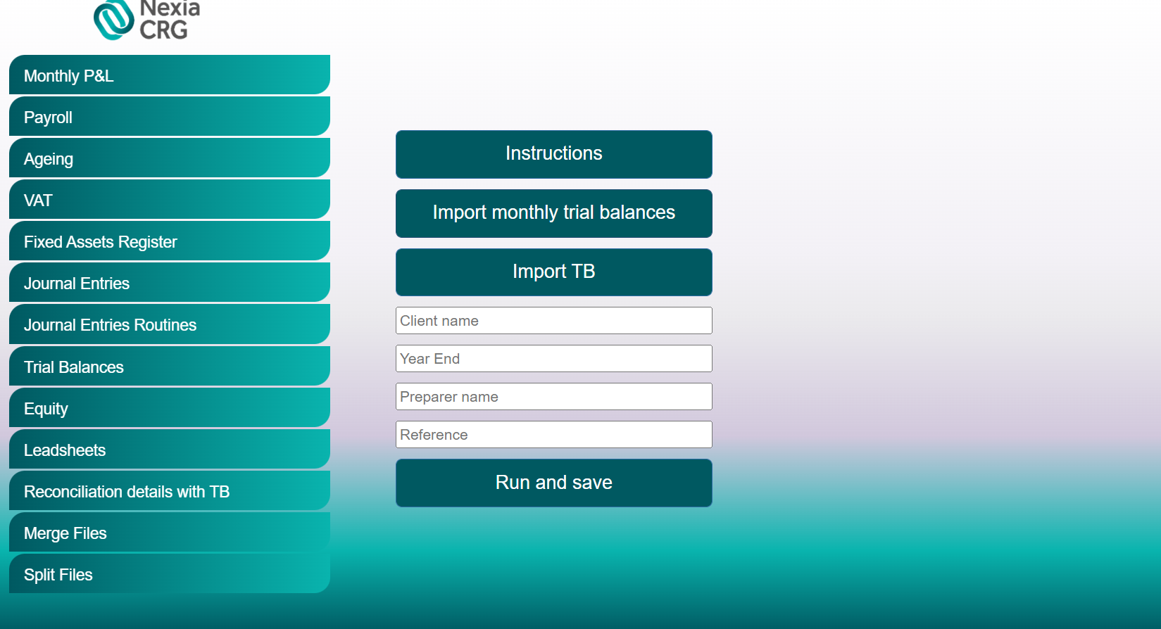

1. Enter the Client’s name and the period end (MM/DD/YYYY) of the audit (Year End), your name (Preparer Name) and Reference number (Reference).
2. Click “Import monthly trial balances” button and import the monthly trial balances.
3. Click “Import TB” and import the Trial Balance Template.
4. Click “Run and save”. Once clicking that, the robot will process your request, and download a file named “Monthly P&L” + “Client name” into your designated Downloads folder.

**Note:** Accounts 609, 709 and 711 are not treated differently from other accounts and may require manual adjustment in the resulted file.

For any issues, questions and/ or suggestions, please contact:

Cristian Iordache, [cristian.iordache@ro.gt.com](mailto:cristian.iordache@ro.gt.com)

Bogdan Constantinescu, [bogdan.constantinescu@ro.gt.com](mailto:bogdan.constantinescu@ro.gt.com)